|  |  |
| --- | --- |
| Server maintenance catalog SOP - SolarWinds Monitoring |  |
| October 23, 2021  Status: Draft | |
|  | |
| Description: C:\Users\spruillj\Documents\HP Proposal Mgmt\Proposal Tools Mgr\Proposal Template\SOW Templates\P048_Group Meeting_1.jpg | |

Important Notice

This Operational Runbook is proprietary to HPE and contains HPE Confidential Information. It may not be disclosed in whole or in part without the express written authorization of HPE.

Version Control

|  |  |  |  |
| --- | --- | --- | --- |
| Version | Prepared by | Change Description | Date |
| 0.1 | SolarWinds Team | Original documentation and initial draft | 05/17/2021 |
| 0.2 | SolarWinds Team | Document revision updates include screenshots, other minor edits | 06/18/2021 |

Table of Contents

[Purpose 4](#_Toc74932602)

[Steps to be followed for putting under Maintenance 4](#_Toc74932603)

[Steps to be followed for placing the Server Back in Monitoring 10](#_Toc74932604)

# Purpose

The document gives detailed steps to place servers under maintenance from SolarWinds Monitoring or remove servers from maintenance if the activity completed before planned end time. The Catalog request can be used for both individual and bulk Servers

# Steps to be followed for putting under Maintenance

1. Open ServiceNow Service Portal link [Home - Service Portal (service-now.com)](https://hpe.service-now.com/sp)
2. Click on **Request Something**

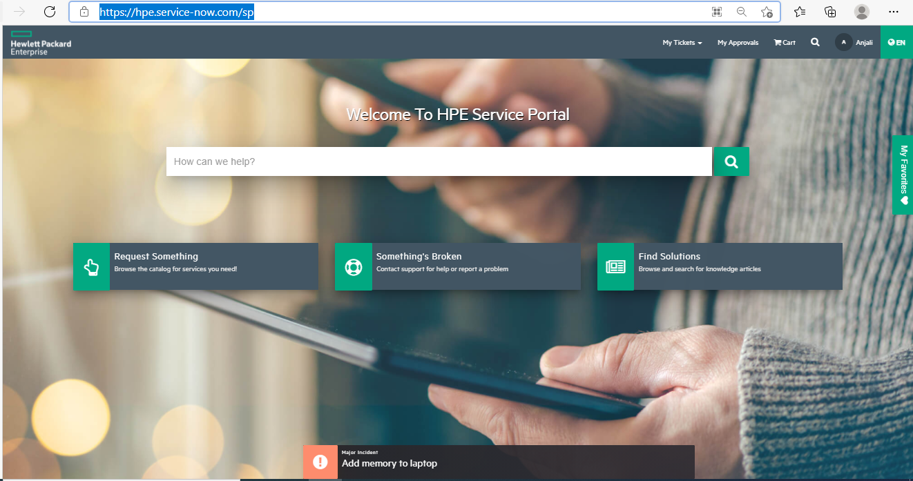

1. Click on **Monitoring as a Service**

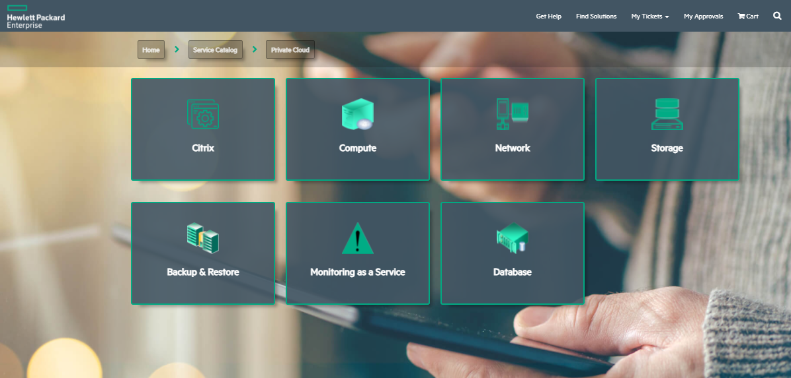

1. Click on **SolarWinds**

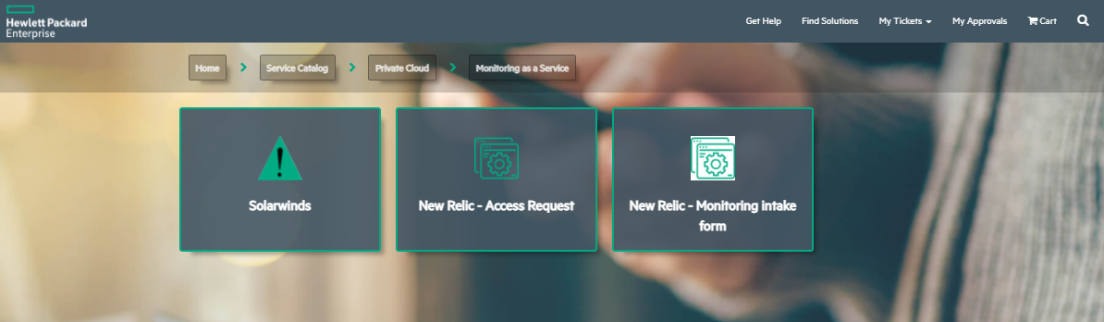

1. Click on **Node (Add/Remove/Unmanage/Remanage)**

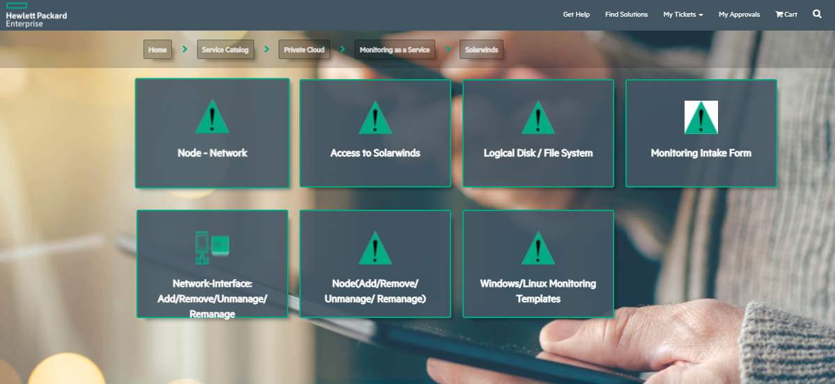

1. Select Type of Action as **Unmanage Multiple nodes**

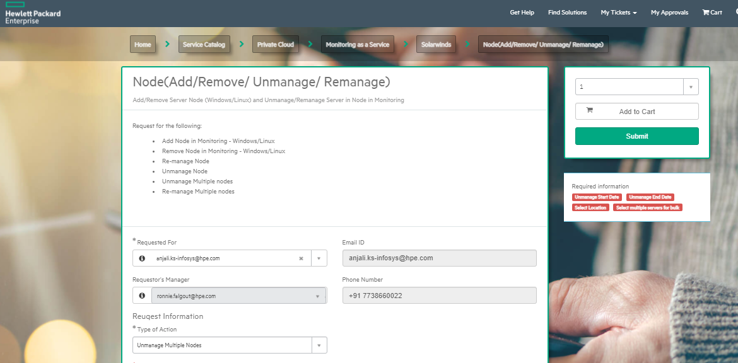

1. Enter the **unmanage Start Date** and time using the **calendar** icon on the side. Please make sure the date is today’s date or any future but not past date. Same with the time

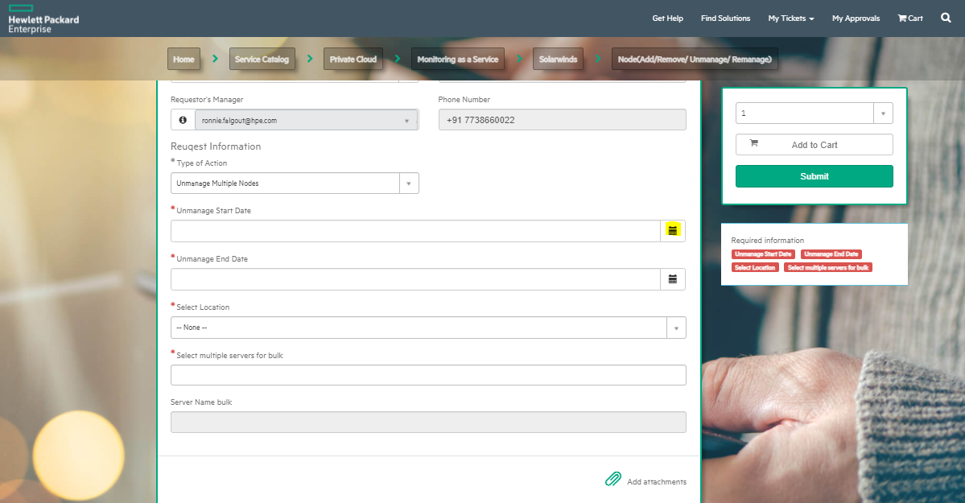

1. To edit time, click on the small **clock** at the bottom of calendar. The time mentioned here is **CST** time

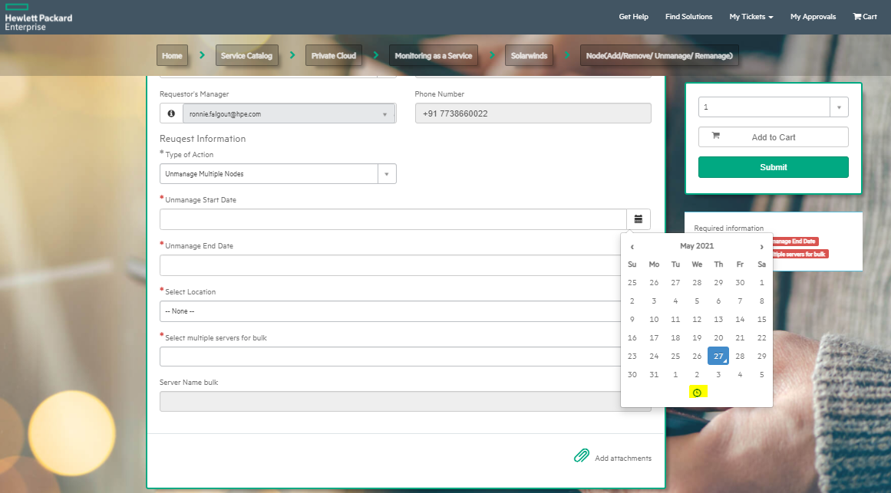

1. Follow the same steps with **Unmanage end date.** For successful execution please make sure the end date is after the start date
2. In location you need to select if the server is in COLO1 or COLO2

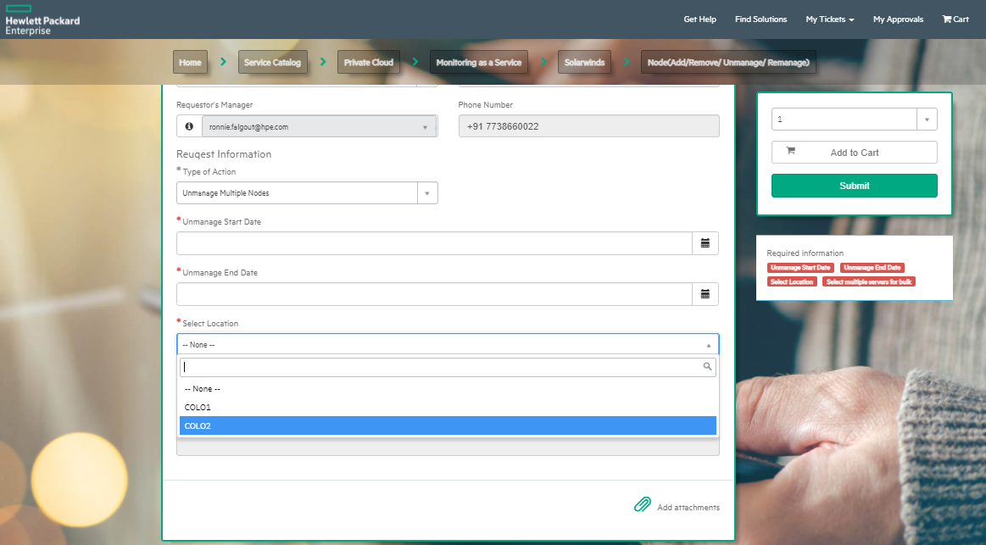

1. In Select multiple servers for bulk, please type the server **hostname**. This field won’t accept IP address as input, it will give an error **No matches found.** Even if you have entered the right Hostname still it is giving the error that means that the location selected is wrong.
2. The Catalog task needs to be approved. Please find the list of approvers below.

|  |
| --- |
| [syed-mubashiruddin.ahmed@hpe.com](mailto:syed-mubashiruddin.ahmed@hpe.com) |
| [regan.alan-infosys@hpe.com](mailto:regan.alan-infosys@hpe.com) |
| [gnaneshwara-reddy.bobbiti@hpe.com](mailto:gnaneshwara-reddy.bobbiti@hpe.com) |
| [ronnie.falgout@hpe.com](mailto:ronnie.falgout@hpe.com) |
| [mustafa.lakkadghat@hpe.com](mailto:mustafa.lakkadghat@hpe.com) |
| [gayathri.mall-infosys@hpe.com](mailto:gayathri.mall-infosys@hpe.com) |
| [prakash-m-s.rao@hpe.com](mailto:prakash-m-s.rao@hpe.com) |
| [pramod-kumar.singh@hpe.com](mailto:pramod-kumar.singh@hpe.com) |
| [saurabh.sinha-infosys@hpe.com](mailto:saurabh.sinha-infosys@hpe.com) |
| [nyerra@hpe.com](mailto:nyerra@hpe.com) |

1. Check for **Request item stage**. If the catalog request is successful, the Request item stage will be in **Completed**

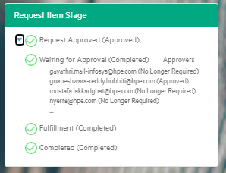

1. In case of failure it will create a manual task for SolarWinds team. Contact [hoh\_infraops\_team-tools@hpe.com](mailto:hoh_infraops_team-tools@hpe.com) in case of urgency

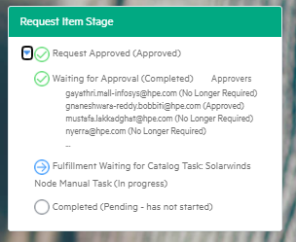

# Steps to be followed for placing the Server Back in Monitoring

The catalog task can be used in the scenario if the activity is finished before the end of maintenance period and the servers needs to be put back under SolarWinds Monitoring. This can be used to re-manage single or bulk servers

1. Follow steps 1- 6 same as unmanage node.
2. Select Type of Action as **Re-manage Multiple nodes**

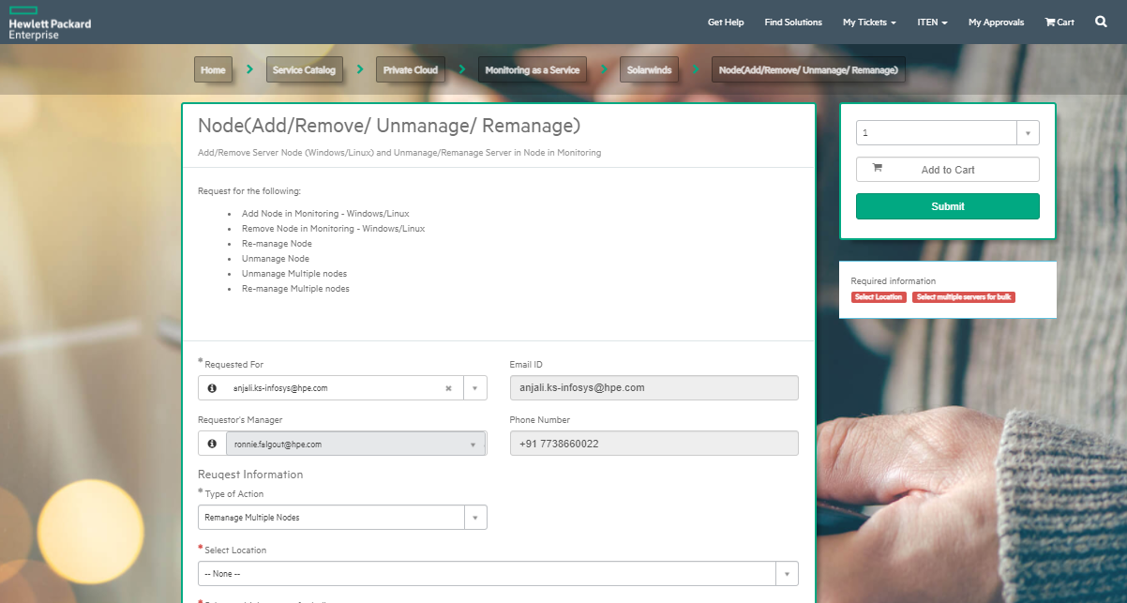

1. 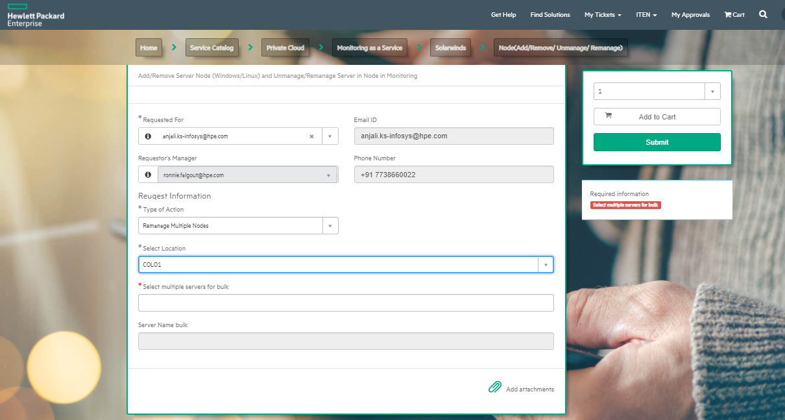In location you need to select if the server is in COLO1 or COLO2
2. In Select multiple servers for bulk, please type the server **hostname**. This field won’t accept IP address as input, it will give an error **No matches found.** Even if you entered the right Hostname still it gives the error that means that the location selected is wrong.
3. The Catalog task needs to be approved. Please find the list of approvers below.

|  |
| --- |
| [syed-mubashiruddin.ahmed@hpe.com](mailto:syed-mubashiruddin.ahmed@hpe.com) |
| [regan.alan-infosys@hpe.com](mailto:regan.alan-infosys@hpe.com) |
| [gnaneshwara-reddy.bobbiti@hpe.com](mailto:gnaneshwara-reddy.bobbiti@hpe.com) |
| [ronnie.falgout@hpe.com](mailto:ronnie.falgout@hpe.com) |
| [mustafa.lakkadghat@hpe.com](mailto:mustafa.lakkadghat@hpe.com) |
| [gayathri.mall-infosys@hpe.com](mailto:gayathri.mall-infosys@hpe.com) |
| [prakash-m-s.rao@hpe.com](mailto:prakash-m-s.rao@hpe.com) |
| [pramod-kumar.singh@hpe.com](mailto:pramod-kumar.singh@hpe.com) |
| [saurabh.sinha-infosys@hpe.com](mailto:saurabh.sinha-infosys@hpe.com) |
| [nyerra@hpe.com](mailto:nyerra@hpe.com) |

1. Check for **Request item stage**. If the catalog request is successful, the Request item stage will be in **Completed**



1. In case of failure it will create a manual task for SolarWinds team. Contact [hoh\_infraops\_team-tools@hpe.com](mailto:hoh_infraops_team-tools@hpe.com) in case of urgency

